Re-defining effective teaching

A pedagogy of difference
Identifying what works in ‘effective teaching’ and what makes ‘effective teachers’ through the voices of Aboriginal students and community members in Northern Australia.

A pedagogy of difference

Re-defining effective teaching
This document presents the outcomes of the first phase of a three phase research initiative. This initiative begins by identifying, through the voices of Aboriginal students and community members, the teaching practices that influence Aboriginal student engagement and learning. The study was made possible by an Australian Research Grant and a partnership with the Townsville Catholic Education Diocese of Townsville schools, primarily in the Mount Isa area. Aboriginal students and community members have expressed clearly what the characteristics are of effective teachers and effective teaching. We use these community voices in this document to ask, what is quality teaching and what makes quality teachers. This document seeks to invigorate a timely discussion about ‘effective’ teaching, given that the National agenda for education is firmly directed toward teacher quality and effectiveness. This document asks teachers to hear the voices of Aboriginal community members and to look again at what ‘effective’ teaching really means.

Brian Lewthwaite
Barry Osborne
Natalie Lloyd
Helen Boon
Linda Llewellyn

James Cook University
Cathy Day
Codie Kemp
Gail Laffin
Tammi Webber
Jennifer Wills
Megan Harrison

Catholic Education Diocese of Townsville

Welcome from community

Catholic Education Welcome

Contents
A pedagogy of difference 1
Re-defining effective teaching 1
Welcome from community 1
Catholic Education Welcome 2
Introduction 5
What is effective teaching? 5
About this document 8
Theme 1: Parent voices – teachers’ understandings and beliefs about students and their communities as antecedents for effective teaching. 9
1. Understanding Our History with Education 10
2. Understanding the ‘Code-Switching’ Required of Our Children 11
3. Understanding Our Perceived Inability to Change Schooling as It Exists Today 12
4. Wanting Teachers and Schools to Hold an Alternative Point of View of Indigenous Students and the Communities They Represent 13
5. Wanting Schooling and Teaching to Affirm Cultural Identity and Have a More Holistic Focus, Not Just on Academic Achievement 14
Essential questions for critical reflection 16
Theme 2: Student voices-developing positive relationships are crucial as a foundation to learning. 17
Essential questions for critical reflection 18
Theme 3: Student voices – cultural bridges are used to promote learning. 19
Essential questions for critical reflection 21
Theme 4: Student voices – students are supported in negotiating the literacy demands of school. 22
Essential questions for critical reflection 23
Theme 5: Student voices – learning intentions are made clear through a dialogic environment. 24
Essential questions for critical reflection 25
Theme 6: Student voices – teaching is differentiated to accommodate student diversity. 26
Essential questions for critical reflection 27
Theme 7: Students’ voices – a variety of practices for causing learning. 28
Essential questions for critical reflection 30
Theme 8: Mechanisms are put in place to support and monitor student behaviors. 31
Essential questions for critical reflection 32
A framework for culturally responsive pedagogy. 33

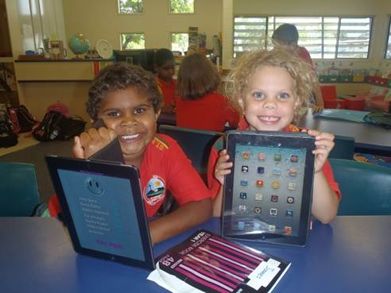

Introduction

What is effective teaching?
This document provides invaluable insight into what every teacher wants to know - what works when teaching Indigenous students? To facilitate this, this document seeks to uncover what truly drives our teaching and by knowing this, provide teachers a clear picture of what facilitates, and what gets in the way, of genuinely effective teaching of Indigenous students.

Although Australia has a long-standing status as a country that delivers high quality education, more recent data from international evaluation assessments such as the Program for International Student Assessment (OECD, 2006, 2010) have categorized Australia as increasingly a low equity-high quality education performer and provider (McGaw, 2006). That is, there is evidence of increasing inequity in school outcomes with a large and increasing achievement gap, especially between Indigenous and non-Indigenous students. Thus, it is not surprising that through the Council of Australian Governments (COAG) all state, territorial and national governments in Australia have more recently agreed to a set of educational priorities and reform directions to reduce Indigenous disadvantage (2009). In The Melbourne Declaration (2008) this agreement aims to ensure learning outcomes of Indigenous students improve to match those of other students through a variety of actions - including, making sure schools and their teachers build upon local cultural knowledge and experience of Indigenous students as a foundation for learning (Ibid, 2008).

Competing voices:

In Australian educational discourse, there is a contest of a variety of methods by which Indigenous disadvantage can be addressed by improving teaching. However, few give consideration to the significance of students’ cultural backgrounds as a determinant for influencing mainstream educational success (Sarra, 2011). Evident within this contest, especially in North Queensland, are voices advocating for improved teaching practice that can assist in improving educational outcomes for students in general and Indigenous students specifically.

A significant voice, not only in Australia but Queensland specifically, is John Hattie’s work based upon his synthesis of more than 800 meta-analyses which identifies the impact of a long list of variables on educational achievement. Hattie (2003, 2009) identifies teachers and their teaching as a major source of variance in students’ achievement. Hattie (2003) asserts we need to focus attention nationally on the specific actions of teachers that influence student learning outcomes. Hattie challenges teachers to ‘know thy student’ and deeply consider the consequence of their teaching upon learning and engage in dialogue with students about their teaching and students’ learning and, by doing so, as he refers, make learning visible (2009).

A pedagogy of ‘indifference’:

Notwithstanding the significant contribution Hattie’s research has on informing teaching practice, alarmingly absent in his account is any discussion of the deeper role culturally located teaching practices and, more broadly, general pedagogy are likely to have in improving student learning for Indigenous students. Hattie’s quantitative research on “teacher effect” and its accompanying list of teaching practices are applied in isolation from the cultural and social context. As enacted curriculum, including teaching practice, must demonstrate links between school and the everyday realities of Indigenous Peoples’ life practices, histories and cultures. By treating all students, however much they differ, as equal in rights and duties, the educational system gives its sanction to the initial (and historical) inequality in relation to culture (Bourdieu, 2008). As asserted by Lingard & Keddie (2013) a ‘pedagogy of indifference’ will continue to prevent marginalised students from accessing the cultural capital that is rewarded within mainstream education.

This document seeks to add an additional ‘voice’ to considerations of what ‘effective teaching’ is. It focuses on a voice that, for too long a period of time, has been missing from the discussion. That voice is from the community members of Aboriginal communities in Northern Australia – from the students, parents and other community members themselves.

As teacher professionals, we make the decisions about what is best. But, what does effective teaching look like when it responds to the voices of the people who tell us clearly what will work for them?

It is important to know and understand our history with education. It’s a history I do not think many teachers know. It might be a part of the past, but knowing helps to build a better future for our children. It is an important history as it helps to understand how many parents and their children approach education today. For many, including my parents it was not positive. School was not a welcoming place. You weren’t made to feel welcome so for every [Aboriginal] person there is that reservation – a mistrust with schools, and with teachers. It’s just too much a part of our history.

So, when our children go to school I think they carry that same sensitivity to school and to teachers. They can sense it and until they are really sure and certain, there will be that mistrust in the background. Until they see something different there will be that mistrust. That’s why it’s those basic skills of making someone feel ‘welcome’ – really welcome are important. Just a smile, a gesture, a comment – all of those things are so important. Even more is if those things aren’t there when you go to a school. We need to receive that gesture, that smile, that comment. If it is indifferent, then that’s telling us we aren’t welcome.

My parents' experience with education was not positive. I picked up on that, and I know what it feels like to not feel welcome – to not be treated like I am welcome. There is a difference between being made welcome and being made to feel like you are not welcome. It doesn’t take much to make you feel either welcome or not welcome. We want our children to feel welcome and a teacher can do so much to make that happen”.

About this document
This document is organized into eight themes highlighted by the study. The first centers on the voices of parents in the community. Parents explain clearly what is important to them, for the children of the community – that is, what encapsulates effective teaching. The subsequent themes (2-8) contain the voices of students and what effective teaching means to them. Contained within each theme is a commentary alongside narratives from the voices of research participants, Aboriginal parents and students from the community engaged in the research.

The purpose of this document is to engage teachers in reflective teaching practice using a framework of culturally responsive pedagogy. The framework seeks to raise awareness of the uniqueness of effective teacher attributes for Aboriginal (and Torres Strait Islander) learners. The document argues that these attributes are effective-ness in a new light and questions, are they not, simply, good teaching practices for all students?

The following is a list of questions for you to consider in light of your current teaching practice. You are encouraged to consider these before reading on.

Theme 1: Parent voices – teachers’ understandings and beliefs about students and their communities as antecedents for effective teaching.
This first theme captures the voices of parents in Aboriginal communities as they discuss what is required for effective teachers and teaching. There was a distinct difference in the content of the responses that came from parents as compared to students. The comments from parents and carers were focused on systemic issues in education, whereas responses from students tended to be associated with tangible expressions of such issues in teachers’ practice. Five such themes were evidenced in the parental comments.

- Understanding our history with education.
- Understanding the code-switching of our children.
- Understanding our perceived inability to change schooling as it exists today.
- Wanting Teachers and Schools to Hold an Alternative Point of View of Indigenous Students and the Communities They Represent
- Wanting Schooling and Teaching to Affirm Cultural Identity and Have a More Holistic Focus, Not Just on Academic Achievement

- Understanding Our History with Education
At the forefront of parents’ responses was their own experiences with mainstream education. Parents expressed a desire for change, but realized that history, collectively and individually, is negative, not forgotten and influenced how they interpreted and responded to their current experiences, especially through the experiences of their children. The historical ramifications of the influence of the consequence of colonial history as expressed by these parents has strong resonance with findings from ethnographies in Aboriginal and Torres Strait Islander history nationally and Indigenous (Native American, First Nations, Aboriginal, Torres Strait Islander, Maori) settings internationally over several decades. As asserted by Wilson (Ibid, p. 381), “Academic success or failure is fully understandable only in its macro-historical, macro-social, microeconomic and macro political context”. It is also this history they perceived that continues to be unchallenged and unchanged and thus perpetuates the inequity in education and parents’ conscious response, and usually negatively, to educational matters individually, locally and nationally today. Effective teaching had to acknowledge this history and was identified as an integral initial step for altered change in practice.
“It takes a long time to build that trust. For some parents it will never occur [because of their past experiences]. So for their children, it might never occur. That wall is really there to keep you safe. Why should I trust [because our past would tell us not to]? So, keep your distance. It’s when we see familiar faces at the school, that’s when things begin to change. You see someone at the school you know [mentions names] and then you have the start of trust. You feel like there is someone there that makes you feel welcome. So you think - that’s a good sign for my child. You have someone who you think will have your child’s interest at heart. That’s what I want. Just to know that someone is looking out after her.”
- Understanding the ‘Code-Switching’ Required of Our Children
Parents understood the nuance of schools and what was privileged for influencing success in schools (Rowe, 2003) not only academically but also socially. These inputs about the social norms and imperatives of schools, especially the language protocols are supported in ethnographies representing Indigenous peoples both nationally and internationally. Lewthwaite et al. (2014) assert that the ‘matter of schools’ and means by which Indigenous students succeed in mainstream schooling is largely grounded in students proficiency in the social form of conduct and behaviours and the symbolic form of literacy and numeracy privileged by schools. Student’s home culture was seen to be incommensurable and discontinuous with school culture and academic success (Clancy & Simpson, 2001; Ladson-Billings, 1995). Several parents understood this imperative and actively sought to inform and equip students in meeting this imperative.
“Teachers don’t know the difference how we are at home and how we must do things at school. I tell my children that to be successful at school they have to ‘be’ a certain way. You can talk that way at home [referring to non-Standard Australian English] but when you are at school you have to speak a [certain] way, even behave a certain way. You just can’t go ‘walkabout’. Get up out of your seat when you want. Put your hand up to ask questions. [My children] have to know how [schools] work. My oldest did really well, then the second. You kind of figure out what is important and what you need to do. Then it works well. It is mainly the English and Maths. That’s what really counts. So you read at home just to make it better for them. We don’t usually do that [at home] but you have to do that if they are going to be success [at that school]”
- Understanding Our Perceived Inability to Change Schooling as It Exists Today
Parents’ comments indicate that they had little influence on the way schools operated, especially an unquestioned operation that catered to the aspirations and patterns of the dominant society only and, as they perceived, made little allowance for difference. These comments about parents’ inability to change or disrupt schooling and teacher actions are commonly mentioned both in the national (Luke at al., 1998; Sarra, 2001) and international literature (Delpit, 1995, p.46). Drawing from Gramsci’s construct of hegemony (1977) parents’ comments gave evidence of their conscious awareness of the invisible mechanism of control by which all schools operate, especially in the impact they have in minimizing the influence they as parents have on existing protocols, in particular at the classroom interface between student and teacher.
“You really feel like you are at the mercy of the school and the teacher. You don’t have any say. You want it to work better for your children [than it did for me], but you can’t control that.”
“We haven’t been able to believe that what [I] say might be listened to. Teachers can make the difference. They can make it good or bad. You watch it at the start of the year. If it’s going to be a bad year [for my child] because of the way [my child] is treated then you can’t change that.”
- Wanting Teachers and Schools to Hold an Alternative Point of View of Indigenous Students and the Communities They Represent
Apparent in the comments from parents was their hope for their children’s education and for teachers’ positive perceived views of their children. In most conversations, participants perceived through their own experience as learners or second-hand through their children’s experience that they had been viewed pathologically by teachers as ‘lesser’ or ‘not as capable as’ [non-Indigenous learners] (Shields, Bishop and Mazawi, 2005). These beliefs, in turn, influenced how teachers interacted with students and parents (Trouw, 1997). As Bishop et al. (2003) assert, at the heart of many school systems’ thinking is a belief or, at least, an assumption that Western ways are superior and that Aboriginal culture and specifically students may bring deficits to classrooms, not assets. Such thinking implies that not only are students’ background experience and knowledge of limited importance to promote learning, but so are their cultural foundations. Deficit thinking or theorizing, as it is called, is the notion that students, particularly low-income, minority students, fail in school because they and their families experience deficiencies such as limited intelligence or behaviours that obstruct learning or that they have little aspiration for educational success (Bishop, 2003; Castagno & Brayboy, 2008; Valencia, 1997).
“Just the way the school thinks of [my child]. That is what is important. Just to believe they are capable and not to ignore them. You really want [teachers] to give your child the best opportunity. Not just think that [my child] will not be a good student. Sometimes I think [teachers] have their mind made up right away. On that first day, you want the teacher to be saying [in their actions] that your child is important and has the [potential] to learn, just like every other [child]. I think sometimes they say, just another [Aboriginal child] that will act up or have learning problems or be bad in the classroom. Just the way [the teacher] might think before they even have a chance.”

- Wanting Schooling and Teaching to Affirm Cultural Identity and Have a More Holistic Focus, Not Just on Academic Achievement
Parents in the study asserted that they wanted the formal curriculum to be the vehicle for the development of personal attributes deemed as important, especially students’ self-beliefs about themselves as learners and culturally located individuals (Barnhardt & Kawagley, 2010; Milgate & Brian, 2013; Sarra, 2013). These parent comments are seeking an alternative to tokenistic recognition of culture that Ladson–Billings (1996, p. 22) identifies as mere “celebrations of diversity”. Instead, they sought incorporation and affirmation of Indigenous perspectives and histories authentically through relationships with teachers and schools that confirmed students’ cultural heritage (Hanlen, 2002; Harrison & Greenfield, 2011). It is suggested, that if teachers hold deficit views of students and their cultures, they have little awareness of the agency they possess for enabling student learning, especially in drawing upon students funds of knowledge as a scaffold to high-status cultural capital (Lingard, 2013). By so doing, if teachers regard students and the culture they represent from an asset perspective, they are aware they have the agency to respond to students’ learning preferences (Valencia, 1997). The parents here were looking beyond mere academic success to include attention to the whole child, as a culturally located individual. As Eisner (1979) suggested, schools, and education in general, are focused on the intellectual growth of the student in those subject matter areas most worthy of study, usually reducing the focus on personal and social goals. Broadening learning beyond intellectual growth is central to culturally relevant pedagogy (Ladson-Billings, 1995; Gay (2000) and consistent with the aims of Catholic Education.
When I went to school, who I was [as an Aboriginal woman] was not important and you were made to feel it was not a good thing. I never remembered anything at school that made me feel proud I was [Aboriginal]. That is not what I want [today for my children].

In summary, participants provided direct evidence on the impacts their parents and/or they themselves have experienced historically in schools. This provides prima facie support for the claims made, and that are supported by Snook et al. (2010) about these important omissions from the work of Hattie (2009) and Rowe (2006). These omissions impact on how teachers interact with students and community and hence help to explain the limited success of schools trying to improve Indigenous student outcomes. It does not mean that Hattie’s meta-analysis or the work of Rowe should be ignored nor even replaced, but it does indicate a fruitful way to investigate ways to deepen teacher understanding of, especially, students’ social and historical backgrounds and in light of this the imperative to re-consider the construct of effective teaching. Parents’ claims give unquestionable evidence of Freire’s notion of conscientisation (1970) drawing attention to the problematic nature of treating all students the same. However much they differ, as equal in rights and duties, [parents believe] by doing so the educational system actually gives its sanction to the perpetuation of long-standing inequality in relation to culture (Bourdieu, 2008).
“That’s why just those basic skills of making someone feel ‘welcome’ –really welcome are important. Just a smile, a gesture, a comment – all of those things are so important. Even more is if those things aren’t there when you go to a school. We need to receive that gesture, that smile, that comment. If it is indifferent, then that’s telling us we aren’t welcome. My parents’ experience with education was not positive. I picked up on that, and I know what it feels like to not feel welcome – to not be treated like I am welcome. There is a difference between being made welcome and being made to feel like you are not welcome. It doesn’t take much to make you feel either welcome or not welcome. We want our children to feel welcome and a teacher can do so much to make that happen. It has changed for my children. When I was at school I never felt there was a teacher that was interested in me or believed in me [as a learner]. Now that has changed, especially at the primary school.”
“Most is that [school] will be a place where [my children] can be proud of who they are. I don’t want them to learn but then put away who they are [as Aboriginal people]. In the past that is what happened to me and that is what I want to see change. A school and classroom that says who I am [as an Aboriginal person] is important. That there can be learning in the school that says who I am is important. Not put it away. I think that’s why so many [Aboriginal people] stay away. It’s not a place where you can be who you are.”

Essential questions for critical reflection
- What are my beliefs, values and understandings?
- How do I build trust with students?
- What beliefs do you hold about your students and their potential to achieve?
- How does Aboriginal and Torres Strait Islander perspectives influence curriculum content?
- What is the Aboriginal community’s aspirations for their children’s education and how does this inform your teaching?

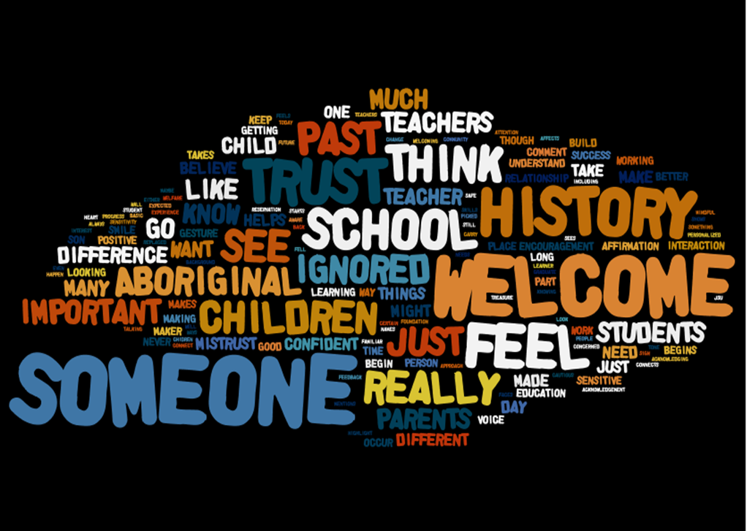

Theme 2: Student voices-developing positive relationships are crucial as a foundation to learning.
In contrast to parents’ conscious awareness of historical inequity, was students’ attention to their everyday school and classroom experiences. Students’ were clear about what was important to them. To students, positive relationship were fundamental to learning. A precursor to positive relationships was an environment where each individual was respected and seen as important.
I think she’s a good teacher because she gives you time. She’s not bossy. But she’s not soft. She takes time to get to know you in the classroom but will talk to you at Coles [shopping store]. My dad noticed that. That is the way it is in the classroom. Because she is that way with us, we try hard to be that way with everyone. Everyone is important. No matter who you are. Then, this all shows in how we behave to each other, not just to her

It is likely that the most commonly mentioned words from student participants, overall, were the words ‘welcome’, ‘care’ and ‘relationship’, words that are vanquished from the dominant ‘effective teacher’ discourse today. Manifest in the description of the relationships was a priority on caring. Caring manifested itself in actions — it supported, expected, it challenged, it affirmed and it was responsive to each individual and their situation (Lewthwaite et al., 2010). It is our understanding that the theorist that is most closely aligned with the community’s admonition for education is Nel Noddings who suggests:
The key, central to care theory, is this: caring-about (or, perhaps a sense of justice) must be seen as instrumental in establishing the conditions under which caring-for can flourish. Although the preferred form of caring is cared for, caring-about can help in establishing, maintaining, and enhancing it. Those who care about others in the justice sense must keep in mind that the objective is to ensure that caring actually occurs. Caring-about is empty if it does not culminate in caring relations (Noddings, 2002, p. 23).
In summary, student participants’ responses implied that a pedagogy of difference for Catholic Education educators needed to be based upon a pedagogical relationship underpinned by an ethic of care (Noddings, 2002; Osborne, 1996).
You can tell she is interested in us all. Every day she lets us know she is interested in us. She tells us about her life and she’s interested in my life. She wants to get to know you. Not just friendly stuff but making you feel you are important and that you can do alright in this subject. In the class she’ll spend lots of time with you and not make a scene about it with the rest of the class. You feel welcome.

Essential questions for critical reflection
- What characteristics of relationships contribute to learning in your classroom?
- What types of interactions characterise your teaching?
- What evidence do you seek when evaluating your classroom relationships?

Theme 3: Student voices – cultural bridges are used to promote learning.
Several students and parents made comments pertaining to local community and the resources of the community as positive influences, both directly and indirectly on their engagement with school and learning. Evident within these accounts is the imperative for continuity rather than discontinuity between school and the students’ life. At a deeper level, is the inferred reason for the assurance of continuity.
You want it to be a place where you feel welcome. That’s the school, but you want it in the classroom too. Where learning that talks about this area and our people are important. There is [someone] who would be a great person to have in the school all the time. He is there now and that makes such a difference he can connect with. Just his knowledge and how students relate to him. I think it sends a message that school needs to do that more…..learning that encourages [my children] in showing who they are and that the school encourages that [Aboriginal people can contribute to the learning process]. The school sees the importance of doing this. It is a priority.

What is evident from these participants is that effective teachers’ confirmed the ‘worthiness’ or ‘worthwhileness’ of community through the use of resources in its many interconnected manifestations – human, historical, and physical. The resource was not simply used as a means to engage students, but more so, as a means to affirm the community that the resource represented.

In the authors’ experience, teachers’ limited affirmation of the community as a resource (Lewthwaite and Renaud, 2009) largely reinforces the lack of affiliation teachers have with both students and community and response to the imperative community members seek for schools to emphasize. What respondents were suggesting was not, simply, that the community be more involved in their students’ learning, but, more importantly, that the school reciprocally confirm the participation of the community through students’ learning. As asserted by Noddings:

When we confirm someone, we identify a better self and encourage its development. To do this we must know the other reasonably well. Otherwise we cannot see what the other is really striving for, what ideal he or she may long to make real. Formulas and slogans have no place in confirmation. We do not posit a single ideal for everyone and then announce ‘high expectations for all’. Rather we recognize something admirable, or at least acceptable, struggling to emerge in each person and community we encounter. The goal or attribute must be seen as worthy both by the person trying to achieve it and by us. We do not confirm people or communities in ways we judge to be wrong (Noddings 1996, p. 192).

It is our belief that such acknowledgment by teachers is a political act, whether conscious or unconscious. Confirmation of community by teachers reveals their attention to, and affiliation for, the subordinated status of Indigenous peoples. Confirmation of community reveals, also, teachers’ awareness of the agency they have for students’ sense of culturally-located self and in challenging this commonly experienced subordination.
When you know the teacher is interested in you, you are willing to share [stories] about your family [history] and other things. I know lots about my family [past history] and he will use examples that relates to some of those areas [from the area]. Battle Mountain was really important story. I had heard about that but not too much. That really opened everyone’s eyes to know that [the battle between the white police and Kalkadoon people] had happened not long ago. There were lots of pictures and stories. It made it really interesting. Now, I can see that learning that was important and why native title is so important…It wasn’t just one sided and he just doesn’t do the talking….It was like there was more than one side to the story. The story was important and he chose to do that. Right here in Mt Isa. Not far away. It just helps you to understand that there is a history here and it does involves [Aboriginal people]. I don’t think many are aware of that. That was really important learning. As a [states career choice] I want those stories to be talked about. Not just the important places around that are special [local country places named] but the stories where there was conflict.

Essential questions for critical reflection
- In what ways can or do I build cultural bridges to facilitate learning in my classroom?
- How do I value student cultural identity in the classroom?
- How do I negotiate and enrich the curriculum to acknowledge and educate about the oppression of, and include, authentic Aboriginal and Torres Strait Islander perspectives?

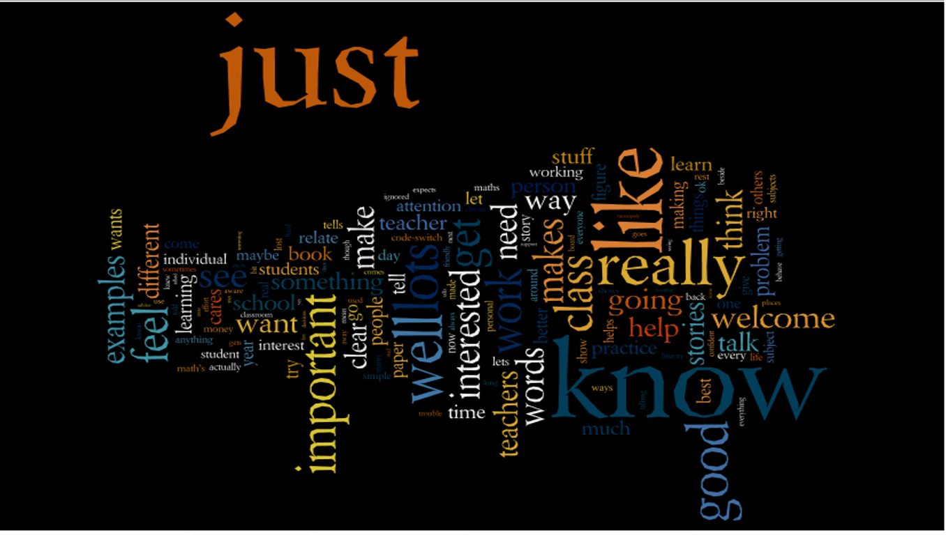

Theme 4: Student voices – students are supported in negotiating the literacy demands of school.
Students’ comments, in contrast to parents, commonly focused on teacher pedagogy, which was then subdivided into several categories. First and similar to parents’ considerations, students identified a variety of ways in which they were supported in literacy learning, often within the context of other learning areas, especially mathematics.
Before reading, she goes over the hard words and maybe has pictures that get you thinking [not just words]. Really slow. It helps to know what will be in [the reading] and what it means. It’s like she knows what words will give you trouble. She doesn’t make you feel stupid, just really supportive. When you are on your own [reading], I can’t understand because it’s just words. You maybe can read those words but not know [and comprehend]. That’s why what she does really helps.
The math[ematics]s problems are just not in words. He’ll show you and you have to work it through. I mean, you can see the problem. Not just read it from a piece of paper. Then you will work it through right there, figuring it out and you’re doing the maths but not really aware that you are. When it’s in a book, you just get lost….because the words don’t tell you what you are supposed to do. Then when you have it, the words come. But they have to after the real thing. Just so the words make sense.
Drawing from the extensive research base which advocates for strategies for assisting students lacking literacy fluency, it was apparent many of these strategies were being advocated for by students. Students were aware they required in school a new way of relating to and using language (Bourdieu, 1990; Halliday & Martin, 1993). Students were being orientated by effective teachers to age-appropriate texts before reading; then reading strategies and writing were taught and repeatedly modelled in context so that words were connected with concrete phenomena (Rose et al, 1999).
In addition, literacy was taught across the curriculum and visual images were commonly used to prompt conversation before textual reading (Yunkaporta, 2010). In all, effective teachers were enabling students’ in their learning, especially in their awareness of students’ language capital and by drawing upon students funds of knowledge and experience as a scaffold to high-status cultural capital accessible in school only through literacy (Lingard & Kiddie, 2013). Without attention to this unquestioned orthodoxy, language became the barrier for student engagement and success.
A good teacher explains really well. They don’t make you figure it out for yourself. They help you with that. There will be lots of examples and you try it or see it in different ways. I like it when in maths you see lots of examples. That makes you feel more confident and then you try. I don’t like it when you’re left to do it yourself. It’s never the same though. In Year 8 and 9 that was good and then in 10 it wasn’t, now it’s good. When it was bad, it was just words. Just words that didn’t make sense. I had to see it.

Essential questions for critical reflection
- What are ways in which code-switching is taught?
- How do I evaluate the ways in which I support students to negotiate the literacy demands across the curriculum?

Theme 5: Student voices – learning intentions are made clear through a dialogic environment.
Pedagogical comments also pertained to the communication patterns of classrooms. Following on from Theme 4 and as we have found in previous studies (Lewthwaite and McMillan 2007, 2010), the language patterns of classrooms were perceived to strongly influence student engagement and learning, and again often acted as a barrier for learning.
I like her teaching when she keeps the important information up front. Really to the point. I know our [Indigenous Education Support Worker] tells us that we need to be able to ‘code-switch’ in the class. Everything is ‘code-switch’ for us. Not just the way we talk but the way we are asked to learn and behave. She says if we can ‘code-switch’, we will be ok. Teachers talk in ways I’m not used to but that’s what lots of teachers do need to be doing more. Help us to see the important stuff and then fill it in a bit – not too much we get lost. When we are learning it is good to be able to use [the language] we are used to. That is good when teachers can help us in the change [from home language to Standard Australian English]…

…I like it when the start of the lesson is clear. You know the focus and then at the end you come back to that. I need to know where I’m going so she makes that good. Just letting you know what you need to know and what to do, so it comes back to that.

Making clear the intended learning was very important to students (Yunkaporta 2010). Clarity of speech and learning intent were seen as crucial for causing learning. The communication patterns were encouraged to be dialogical rather than univocal, voluntary rather than involuntary, both of which are inherent within Hattie’s notion of making learning visible (2010).

Listening, for both students and teachers, was seen as important as talking. Teachers’ under-talking was preferred over their over-talking, especially in communicating complex ideas. Making provision for students to use home language in the classroom was viewed positively as a support for learning (Jorgensen et al 2013).

Essential questions for critical reflection
- In what ways do I make expectations of students (both behavior and achievement) more explicit?
- How and when do I give feedback?
- What effect does this have on student learning?

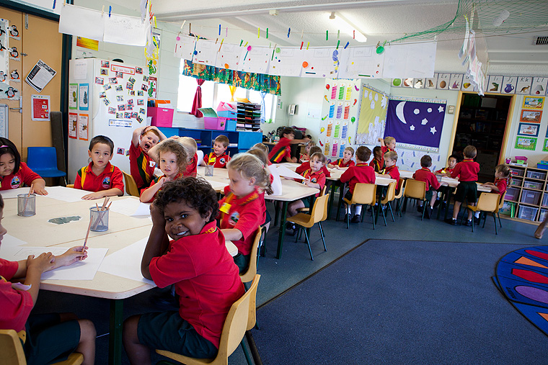

Theme 6: Student voices – teaching is differentiated to accommodate student diversity.
Further on pedagogical matters, students discussed how effective teachers accommodated rather than assimilated students in classrooms, especially in the learning. Evident in their comments was evidence of classrooms operating under guiding principles rather than imposed and restrictive rules.
Right from the beginning I knew this year was going to be good. She makes it clear by what she days and what she does that each student’s learning is important. You could see it right away. I knew her expectations had to do with her believing in us. That’s what I want – teachers that believe in me.
You pick up on whether the teacher places importance on me learning. In some classes, if you are left behind, that’s tough. In [a class] everyone is expected to learn and not stop others for learning. Everyone wants to know where they stand and that everyone is equal. No favourites. Not just the person that gets it, or the ones that don’t get it. There has to be a message that each student’s learning is important.

Students made mention of the importance of high expectations being encouraged for classroom behaviour and student performance, especially in terms that everyone was to engage in learning and was allowed to learn.

Especially important was an organisational structure that provided time, opportunity and support for students to learn and show learning. Also, working for learning allowed for assistance and feedback from peers inferring a classroom grounded on reciprocity rather than individuality.

These comments are consistent with Berger’s (2007) reflections of previous assertions about teacher expectations and positive learning environments for Indigenous settings. He suggests that a warm and caring environment where a teacher is seen as part of ’the team’ and maintains high expectations for all students taking into consideration their diversity and how this will be accommodated, a principle commonly cited in the Indigenous education literature (Clifton and Roberts 1988; Hudsmith 1992; Osborne, 1996; Watt-Cloutier 2000).

Essential questions for critical reflection
- In which ways do I differentiate my teaching to accommodate student diversity?
- How do I take what I know about my students and their unique qualities to influence their learning?
- Do I have goals for each student?
- How have I identified each student’s gifts and talents?
- How do I use this information as foundation to collective learning?

Theme 7: Students’ voices – a variety of practices for causing learning.
Students were able to clearly articulate the things that teachers do to make learning happen. Students were asked, “If you have a new teacher next year, what do you want her to do to help you in your learning?”
I think I am doing much better this year, already. He makes things really clear. I know at the start of each lesson what we are doing. He shows really [it] carefully. There are lots of examples [in the instruction] and [for me] not too fast. I get time to think and practice. If I need help I can get help. At the end of the lesson, he lets us know how we did. I’m not that confident and that really helps.

I only liked geography because he made it really relevant. It had to do with the Mt Isa area and he reminded us of what the areas were [maybe using a map or a photograph]. We would learn difficult things but they related to our country here. I could relate to what he was saying…I thought that was important he took [the] time to find that out.

These two commentaries (left) provide some initial insights into practices commonly identified by students and to a lesser extent by some adults as contributors to learning. The mention of being ‘talked to’, or ‘copying notes’, or being ‘alone’ in learning and ‘listening to learn’ were the most common negative references made by participants suggesting that hierarchical and univocal classrooms, although maybe well-disciplined or managed were not perceived as favourable environments for learning.

In all, students identified over 20 teacher practices that contributed to their learning. In good teaching practice, respondents mentioned that the learning intentions were made clear and that modelling and demonstrating were common. Visual images were commonly used to inform. Repetition and focus on mastery were emphasized. Time provision was made to gain mastery and process learning.

Learning was assessed in a variety of ways, not just in written form. Learners were given personal and timely feedback to support next steps in learning. Collaboration and reciprocation amongst students and teacher in learning was seen as important. The teacher and students involved each other in a student’s learning. It was seen as vital that students were receiving individual attention and given feedback and affirmation as they learnt.

Story-telling and the use of narratives focusing on relatable subjects were significant in promoting engagement and learning. Learning was not abstract; instead it was connected to students’ lives and prior learning, in other words it was meaningful. It focused on knowledge, skills, attitudes and values and was located in local context and connected to students’ lives.

Learning was enriched through ‘working to end’ type projects that promoted independence and collaboration, creativity, perseverance, and self-evaluation of progress towards tangible end products. Literacy and numeracy development were emphasized explicitly in the learning. Developing fluency in these areas was seen as a priority for students who recognised the capital which rewarded success in schools.

Respondents commonly mentioned their lack of symbolic fluency (working with letters and numbers) as an impediment to their progress in school, but also identified a high regard for achieving this fluency and teachers that gave explicit attention to the development of such fluency. Despite this high regard for symbolic fluency, what was learned was not to be at expense of students’ cultural background. Instead effective teachers used this as a medium to engage students and support their learning.
He’ll do it [show the class]… with lots of examples…. And then we’ll try it and come back [to full class] and he’ll do more examples… maybe we work out alone or in pairs…making sure we know it and then moving on. Not fast. Just taking his time. He’ll talk about where people are getting in trouble [with the learning] and so helps me to see where I might go wrong.

Most of these practices have been voiced to us as researchers in previous studies (Lewthwaite and McMillan 2007, 2010; Osborne, 1996, 2001) and are commonly cited in the Culturally Responsive Pedagogy (CRP) literature (Bishop 2003; Castagno and Brayboy 2008) but are largely absent from the current effective teaching discourse.

Students were clearly articulating the impact of effective teaching that allowed them to access and negotiate the norms of Australian schooling. As we have suggested previously (Lewthwaite and McMillan 2007, 2010), we believe many of these practices serve students in negotiating mainstream school transition; that is, they serve to support students in transitioning daily from students’ home experience and familiar culture thus encouraging continuity between home and the classroom. As well, many of these practices are commonly identified as effective supporting learning in the mandated practices many North Queensland schools are experiencing today, especially as advocated by the Explicit and Direct Instruction models.

Likely in contrast to these perceived prescriptive pedagogical frameworks what is evident within these accounts was how learning needed to be personalised rather than be uniform, advocating for a learner-centred approach grounded in the local context.
He wants to get to know you. Not just friendly stuff but making you feel you are important and that you can do alright in his subject. In the class he’ll spend lots of time with you and not make a scene about it with the rest of the class. You feel welcome.

Fostering a pedagogy of difference is built upon the imperative on securing conditions of trust, an aspect of teachers’ work that is not made explicit or considered in the nation’s narrative on effective teaching today.

Essential questions for critical reflection
- What are my practices for causing learning?
- What are my leadership and teaching styles?
- How do I build mastery in my students?

Theme 8: Mechanisms are put in place to support and monitor student behaviors.
Finally, and likely most significantly, students most commonly mentioned the importance of relationships and expectations being the cornerstones for positive student-teacher interactions and classroom environments. Students openly talked about ‘non-learning’ environments where teachers were reactive to student off task behaviours with little awareness of the importance of establishing positive relationships as the foundation for constructive learning environments for the development of individuals as leaners socially, intellectually and culturally.
He’s straight up. He’s there to help and if you muck around, you’re going to lose out. I like that because you know where you stand. In other classes you are made to feel you’re not really worth the teacher’s time. I know the story. It’s like I’ll give up. You don’t get away with not doing well. It would be easy to just to say, well he’s not going to do well, but he’s clear everyone should be giving their best effort. He’s on you but in a good way. I like it when you know that they are really interested in how you are going. Not just let you to do poorly. We talk about that. He’s a good sort. Some are friendly but he is too, but more really interested in how you are going [in all parts of your life]. I got a test back and he said I should have done better and I let myself down by not studying. Most wouldn’t do that. You have to work in his class…He says that…You know what you will be doing that day and what you have to learn. It’s good when you know that.

Participants asserted that the formal curriculum learning experience was underscored by a strong relational foundation which was the predetermining influence on learning. This attribute is silenced within the national discourse on teacher effectiveness.

Effective teachers were not identified as knowledge experts; instead they proactively sought through genuine respectful relationships the development of personal attributes beyond academic achievement, especially students’ self-beliefs about themselves as learners and culturally located individuals (Barnhardt and Kawagley 2010). The acknowledgment of this affective and likely unquantifiable dimension was unequivocally the foundation for current and future learning success.
I don’t feel like I’m different in my class because of my complexion [skin colour]. But I do feel like I am different. He wants the best for everyone, but I know he wants me to do well [as an Aboriginal male]. I want to too. I think he just has that extra [belief in me] because you can sometimes think no one cares. I know others care, but he makes it clear. I think that’s good. I like it that way. We talked about next year and he knows what I want to do and I felt there was just that extra support [for me as an Aboriginal male].
It’s more about what she’s like. You go into her class and you are going to work and learn. In another class you aren’t going to work and learn [it is decided unconsciously by students before we get there]. She wants you to learn and you think she is working with you to help you to learn. There’s no interruptions, because we know she’s working with us. The rules are clear. She teaches clear. Harder stuff for some, easier for others. No one gets frustrated. You want to do your best. She takes her time. Lots of support. She’s really nice. Yes, she can be mad but it’s when we aren’t doing our part. That’s what she says. She’s working hard to do her part and expects us to do ours. Makes it clear. Talks to you well, like a person. If you’re not doing it, she just does it quietly. I don’t like it when there’s someone being told off. It’s usually [in classes] where [the students] don’t think [the teacher] cares. You don’t matter. She just expects a lot from us ….. she expects lots from herself, I guess. She’s [a] new [teacher]. We do lots of different things [in each class]. Maybe from the book, or from the board, or an activity. Changes it up, but it all makes sense. Different ways of saying something [about the same idea]. She doesn’t come across as the expert [like some teachers]. Much more like a real person, not a teacher.

Essential questions for critical reflection
- How do I include students in setting classroom expectations?
- How do I communicate these to students on an ongoing basis?
- How do I uphold the learning expectations of the classroom?

A framework for culturally responsive pedagogy.
Be a teacher of consequence.
The following table provides detailed description of the attributes of effective teachers and a responsive pedagogy as identified by the research. It is important to note that it represents, primarily, low-inference behaviours that would typically be easy to observe in a teacher’s practice. In all, the behaviours not only refer to what is taught but, also and more importantly, how the teaching unfolds and the priorities in their learning. At the heart of this illustration, and constantly asserted by students and parents, is the importance of a teacher’s beliefs and understandings about their students and the community they represent. These effective practices occur because teachers accept that they are the central players in fostering change, first in themselves by altering their beliefs about students and the cultures they represent and, then, working collaboratively towards an environment where practices acknowledge the cultural capital which students possess and the culture of schools they are trying to negotiate. All attributes are consistently mentioned by community members as attributes of teachers of consequence. Also of note, is how community members identified that these characteristics of effective teachers are currently commonly being experienced in the Catholic Education Diocese, suggesting that the attribute of care claimed in the mandate of Catholic Education is being realised in current practice. That is, the imperative to “provide students with more than just academic instruction. Students from Kindergarten through to Year 12 are educated to develop academically, spiritually, socially, emotionally and physically to become compassionate and contributing members of our world” (Queensland Catholic Education Commission, 2009).

Category | Description
What are my beliefs, values and understandings? | Teachers have the potential to effect reconciliation and redress educational inequities. Building trust through is a considered imperative that influences action. An ethic of care is the foundation for all teaching practices. The belief that all students can achieve to the level expected for their age, despite, and also due to, a diversity of knowledge, culture, language brought to school from home. All students are regarded as having the capacity to learn. Knowledge of the legacy of Australia's educational history and Aboriginal and Torres Strait Islander perspectives on curriculum content endows teaching with respect, humility and flexibility. Awareness of community aspirations for their children's education informs teaching.
What characteristics of relationships contribute to learning? | The teachers' role is to facilitate learning; this is achieved through respectful, positive and warm interactions with students. Teachers communicate their regard for all dimensions of learning, including social development, not just academic achievement. Teachers can demonstrate their care for students through verbal and non-verbal interactions outside of the classroom, and pursuit of high expectations in the classroom.
How can building cultural bridges facilitate learning? | Valuing students’ cultural identity includes showing respect for students’ home language and knowledge, family and community, values and beliefs. Furthermore, both cultural knowledges and values, and relatives are welcomed into the classroom and used to scaffold children’s learning. Education about oppression and authentic Aboriginal and Torres Strait Islander perspectives are included in the curriculum.
How do I teach literacy? | Literacy is taught from a foundation of spoken language. Code switching between Aboriginal English and Standard Australian English is explicitly taught. Students are orientated to age-appropriate texts before reading; then reading strategies and writing are taught and repeatedly modelled in context. In addition, literacy is taught across the curriculum as the vocabulary, language features and text features of each curriculum area are explicitly taught. Shared reading is common. Visual images are commonly used to prompt conversation before textual reading.
How do I make my teaching explicit? | Expectations of students both in behaviour and achievement, and the direction of future learning are clearly and repeatedly communicated to students. The knowledge and skills needed by students are explained and modelled in a variety of ways especially through concrete example. Constructive feedback is regularly given to students as they learn. There is a tendency towards explicit instruction, emphasizing a gradual release of responsibility, but inquiry-based learning is encouraged, especially in regards to student initiated questions and ideas.
In which ways do I differentiate my teaching to accommodate student diversity? | All students are unique so multiple learning trajectories and experiences that cater for a variety of learning preferences are provided. The teacher establishes individual goals for student achievement, gives individual feedback and provides intervention for students not meeting expected achievement. Gifted students are identified and supported for extended learning even if literacy levels are low. Individual strengths of students are used as foundations for supporting collective learning.
What are my practices for causing learning? | The teacher behaves as a learning facilitator rather than an authority figure and students are given choices, open ended, experiential, group and outside activities from which to learn. The use of narrative to provide context for learning is frequent. Visual imagery is used to prompt engagement and support learning. A holistic approach is usually taken, in which information and skills are chunked and scaffolded, and connected to prior knowledge. Students are provided time to gain mastery of skills, to reflect and to self-assess, especially through tasks that involves working to end type products. Individual feedback is given and learning success is celebrated. Communication of ideas, especially abstract tasks, occurs orally when students are engaged physically with learning tasks. Explanation of ideas is succinct. Teachers under-talk rather than over-talk.
How can I support and advance student behaviour? | Students contribute to the setting of classroom expectations, which are clearly and consistently communicated to students. The encouragement of cooperative behaviours, engaging and accessible tasks and use of routine decrease the need to manage student behaviours. Off-task behaviour is managed promptly with less provocative techniques such as non-verbal, proximity, pause and wait, close talk (private reprimands) or group reprimands. The learning expectations of classrooms are not compromised by misbehaviour.
What is my role in supporting student health and wellbeing? | Student health and wellbeing underpin academic and social development. Students with individual needs, such as hearing loss, have access to support services. Strategies advocated by specialists are enacted in the classroom. In addition to creating a supportive learning environment, vigilance in detecting the need to refer students to specialist services is the essence of an ethos of care.
How does the school context in which I teach assist learning? | Indigenous staff that are positive role models and engage with students and family are critical members of the school. Schools support teachers’ pursuit of student academic and social outcomes by providing an accessible process by which students and community can be included in school decision making. Schools provide staff time to visit families at home and organise cross-cultural training from community Elders. Strategies to maximise student attendance at school include facilitating student re-enrolment and transitions from other schools and supporting students’ educational pathway. School administration provides professional development for Aboriginal or Torres Strait Islander teacher aides to maximise their teaching roles. School provides access to cultural peer support and role models for Aboriginal and Torres Strait Islander students.

Plan of action

Based on this document, and its questions, consider and identify targets for action. List these and how each will be enacted in your classroom with your students?

Targets | Actions required

